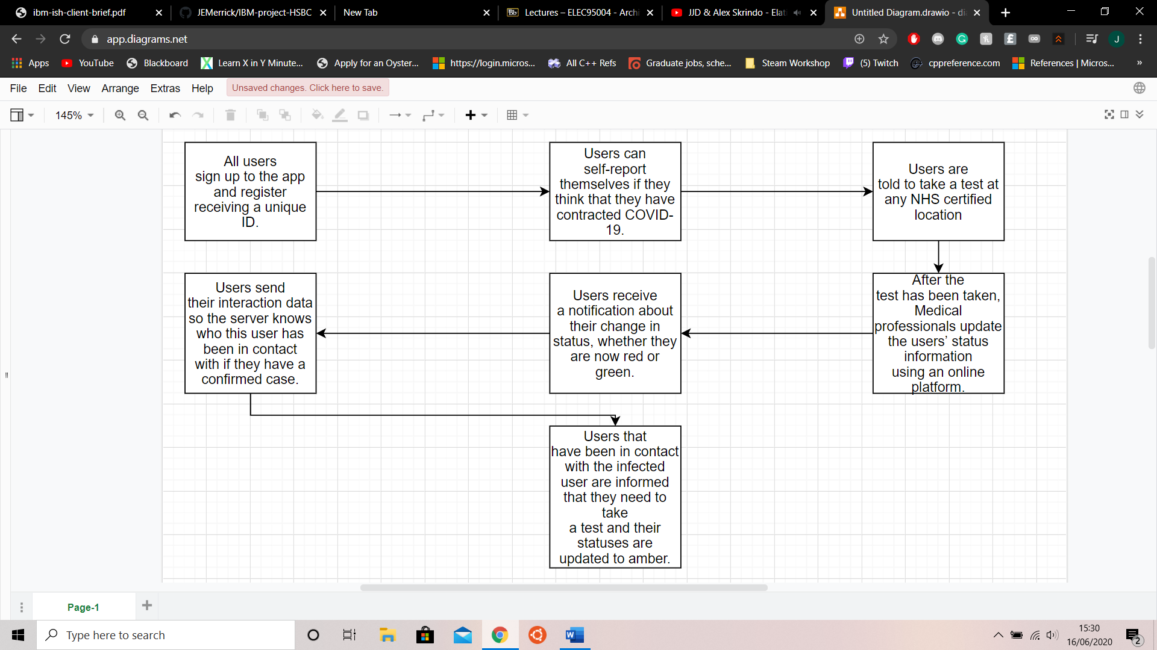

On the right-hand side, we have a diagram of our system in practice. As shown, our system is easy to use. Users have to register with the app which they can find available on the Google Play Store and Apple’s App Store. Once registered the users are given a unique ID. Whilst users have a Bluetooth connection, whenever they encounter another person with the app for larger than a threshold period, this exchange is documented.

Users can choose to report themselves if they fear that they have contracted COVID-19. Users are then directed to take a medical test which is booked through the track and trace system ranging from hospitals, drive through clinics, mail order testing services and doctor’s surgeries. Once the test has been taken and the results have come through, users are immediately alerted of the results as soon as NHS staff are able to document the test results.

If a user is found to have contracted the COVID-19, the exchange data(that was previously mentioned), is sent to the track and trace system, with the system updating the cone of users to have been designated an amber status. These users are told to have a test if they have not previously done so.

Why this is a good idea?

Minimise server-side data, having only needed the unique ID and status of certain users.

Reduces load on the system as interactions are only stored and sent on a positive result.

Medical professionals can update the status of users quite easily, only needing to change the status.

Any interaction involving an infected user is updated by the system and requires no real human update.

Minimises workload of users and most of the flow is done by the system.